CleanEase

Introduction

Clean Ease provides world-class Home cleaning services with a flexible pricing option. We have a group of certified Home cleaners in Bangalore and Chennai. Our main aim is to ensure your convenience.

Admin Functionalities

Admin credentials

email : admin@gmail.com

password : admin@123

Use these credentials to log in and click the Admin button in the Navbar to go to the admin page.

**1. Admin Dashboard**

The admin dashboard provides an overview of admin functionalities like Bookings , Services ,Addservices ,Users ,Quotes. Here's a screenshot of the admin dashboard with all the bookings made by the users.

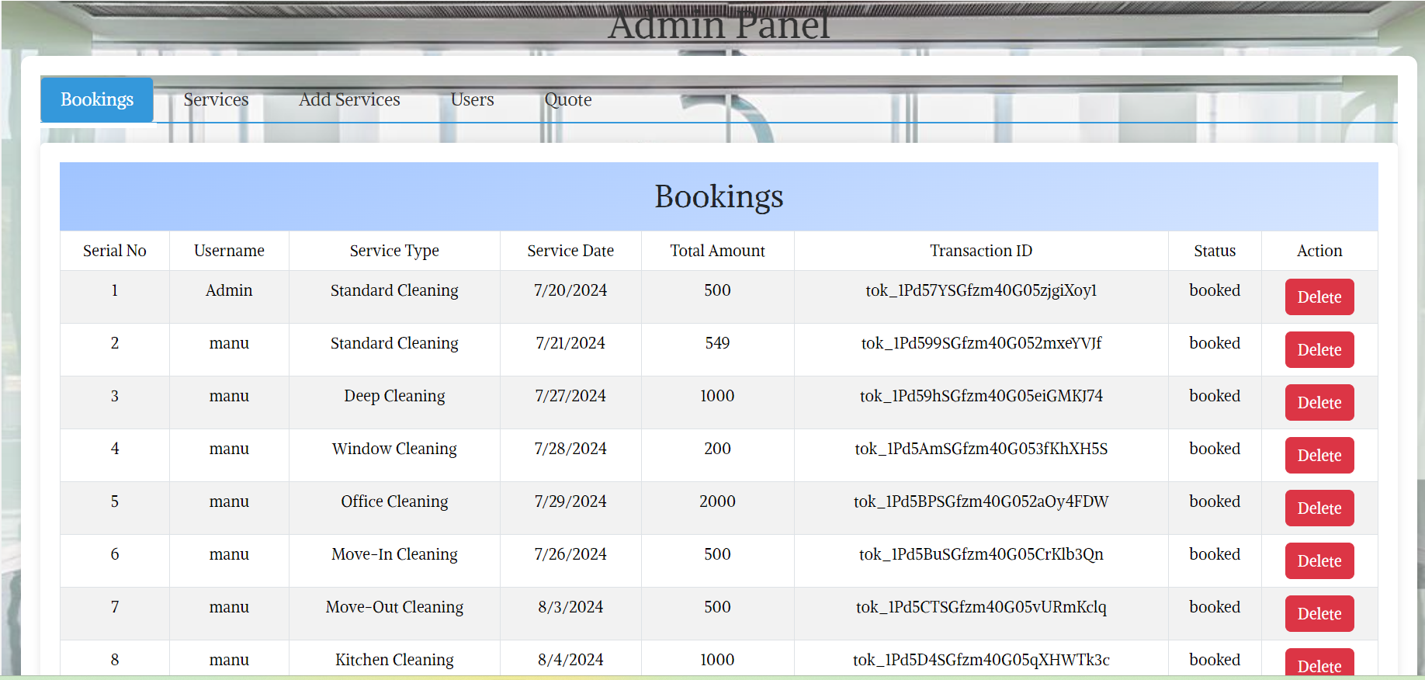

In this bookings admin can delete a booking and it will reflect on the users booking page.

**2. Manage Services**

Admins can edit and delete services from the platform. Here's how the service management page looks:

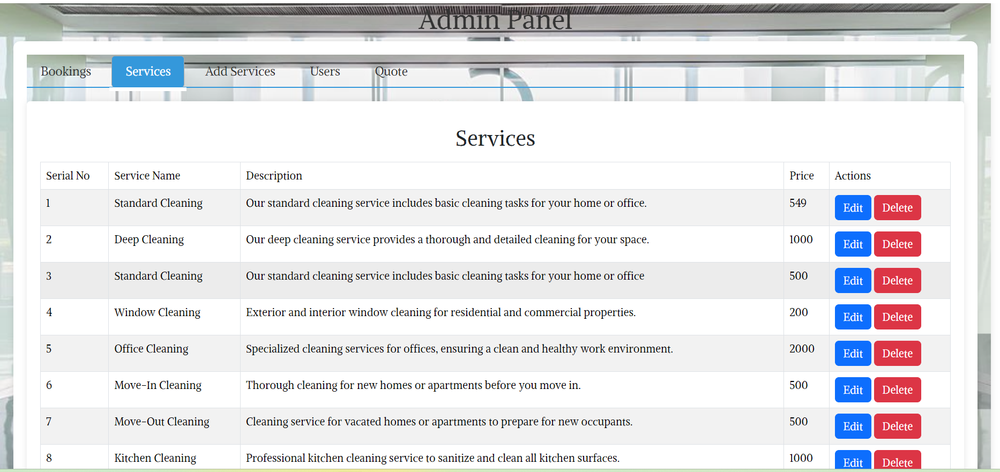

### 3. Add Services

Admins can add services from the platform. Here's how the service management page looks:

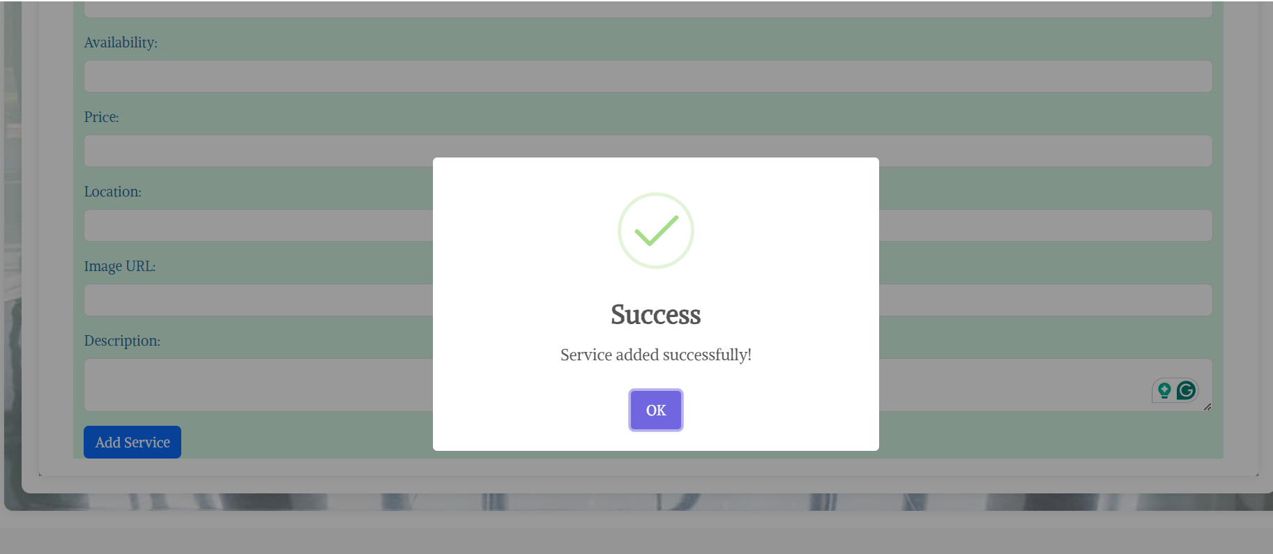

### 4. Manage Users

Admins have the authority to manage users, including promoting users to admins or deleting user accounts. Below is a screenshot of the user management page:

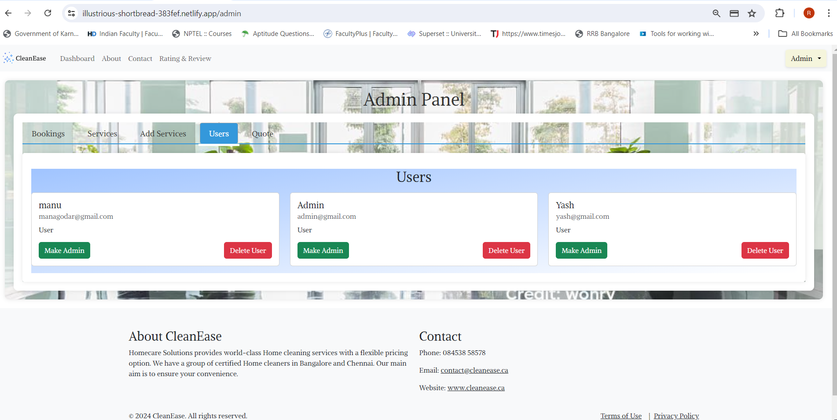

### 4. Quotes

Admin can the quotes sent by the users .

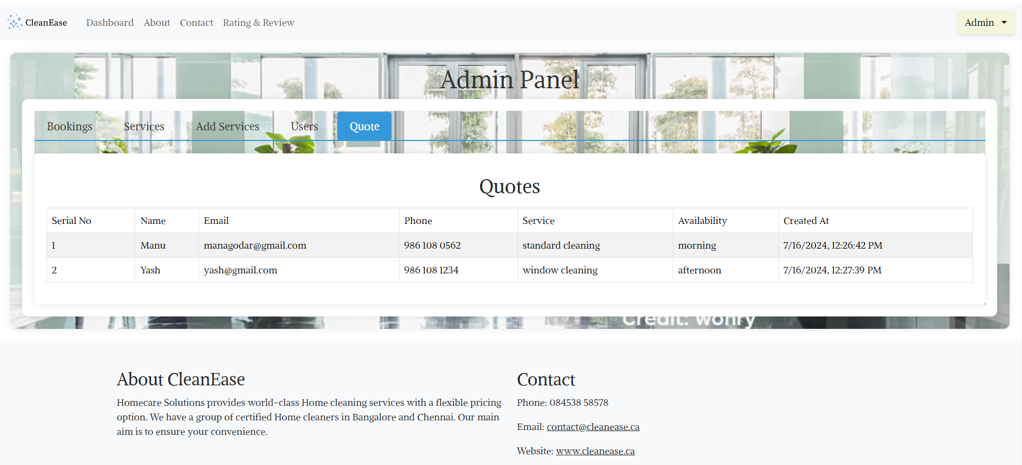

## User Functionalities

### 1. User Dashboard

Upon clicking in, users are greeted with a personalized dashboard displaying a landing page. And click get started to experience the website. Here's a snapshot of the user dashboard:

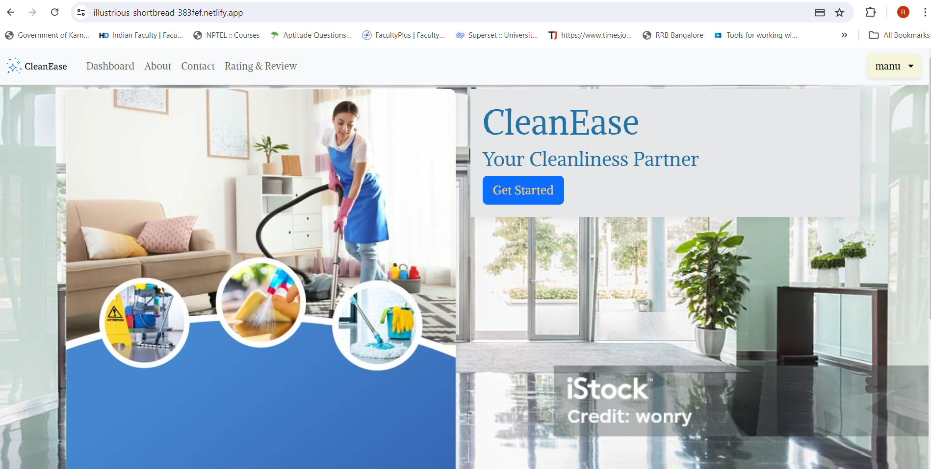

### 2. Register

Users can create an account by registering first.

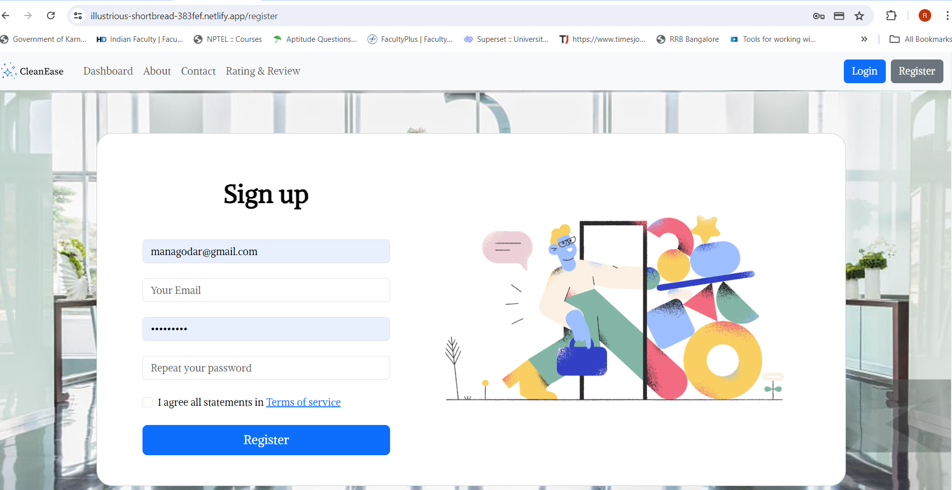

### 3. Login

Users will be redirected to the login page after registering . Remember to login To use all functionalities.. If you are encountering problems it means to login...

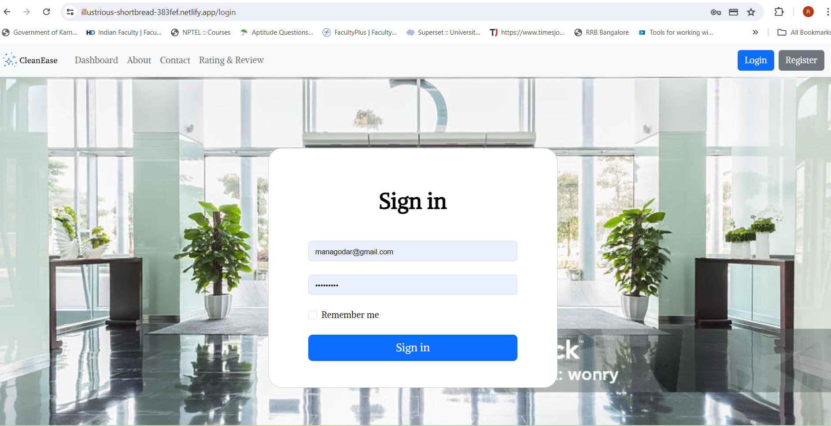

### 4. Home

After logging in users can see the home page. If the user is Admin he will see admin button to go to admin page, but if not admin button will not show up

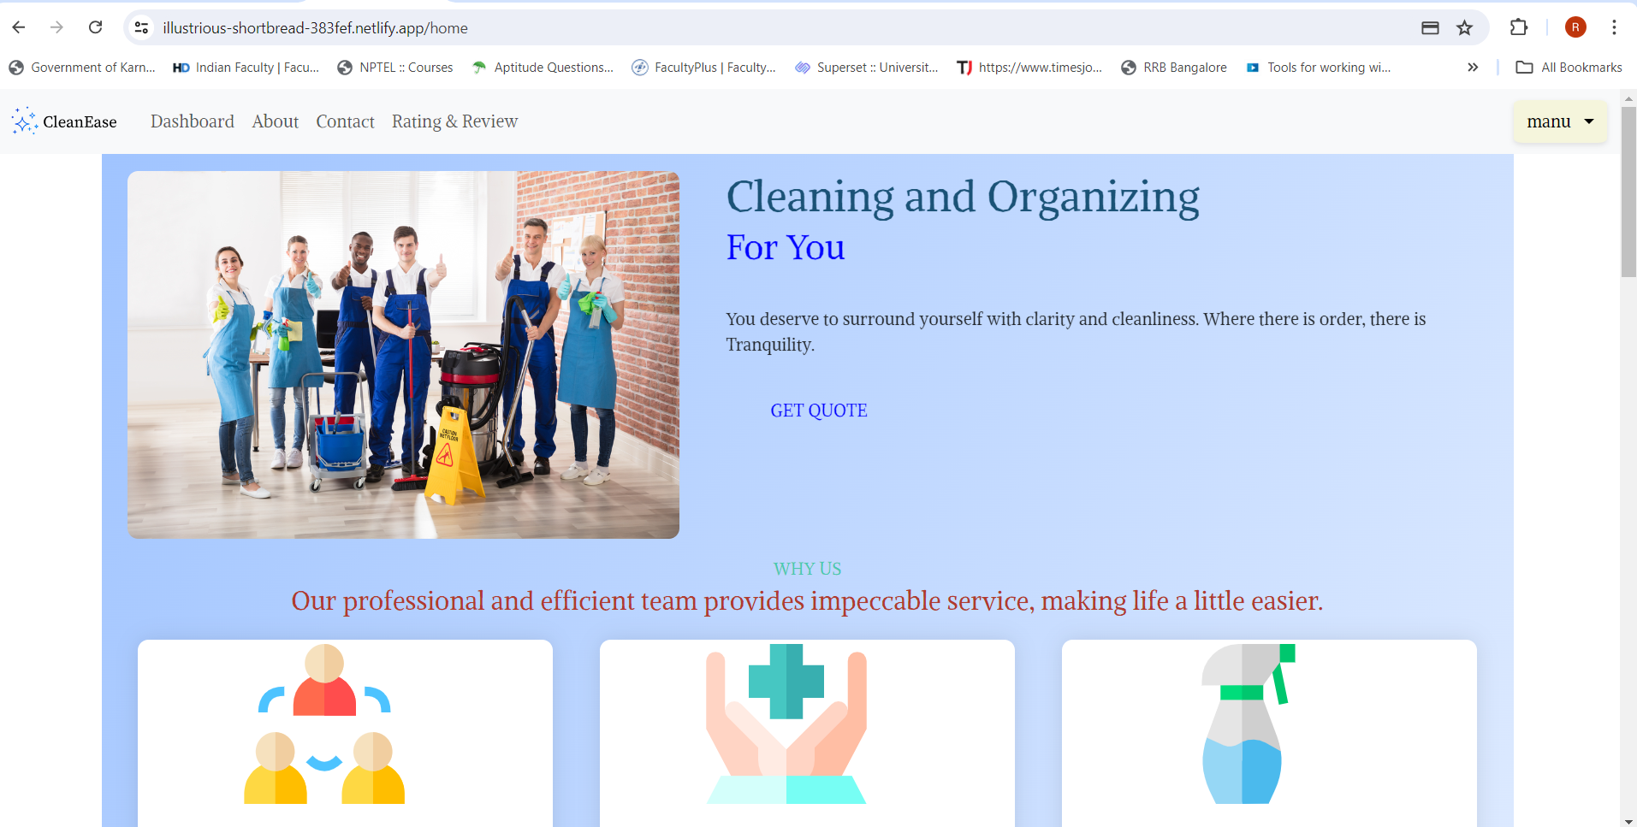

### 5. Quotes

In the home page users will see get quote button by clicking the button a modal will show up to a send quote to the admin.

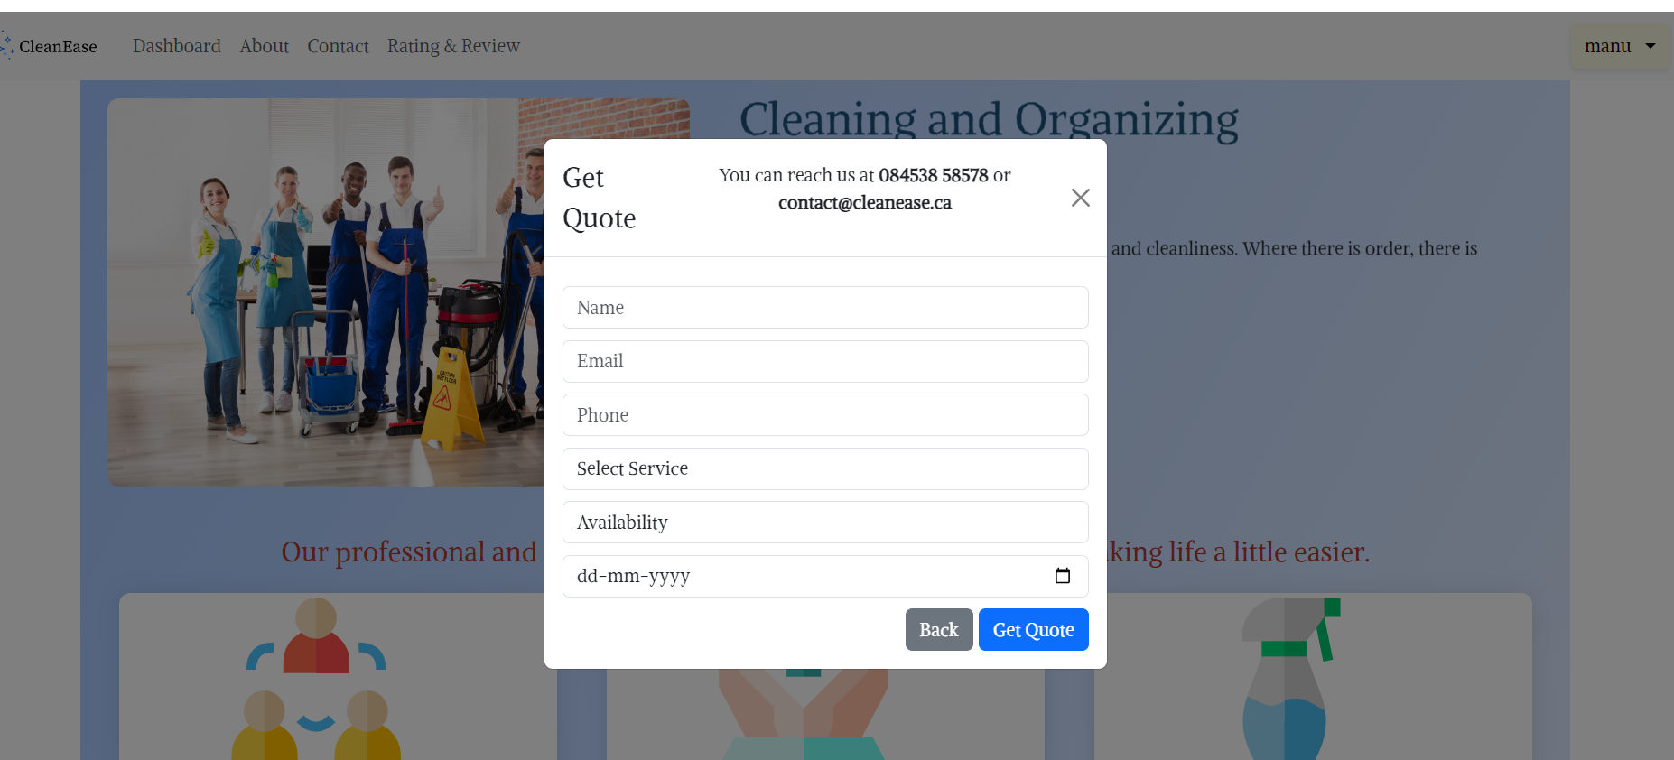

### 6. Browsing Services

Users can see the available services and can search and filter by service availability and location. And user can sort the services by pricing too. Select date is to pick a date for booking.

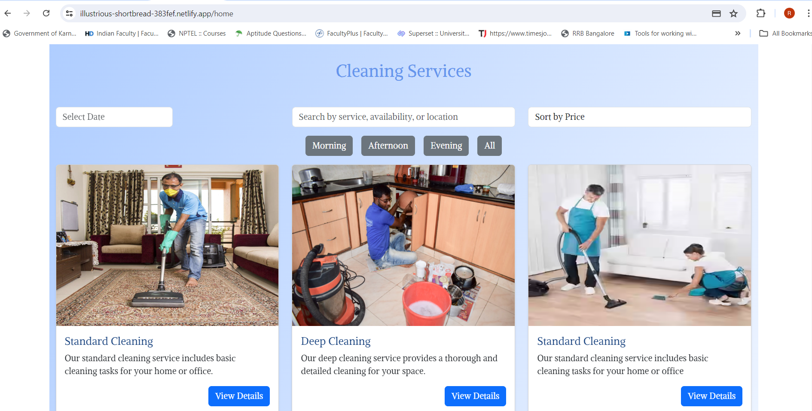

### 7. Booking Services

Users can see the booking details and if the user is not logged in the name will not show and same for the date also and if the user is not logged in the booking will not happen.

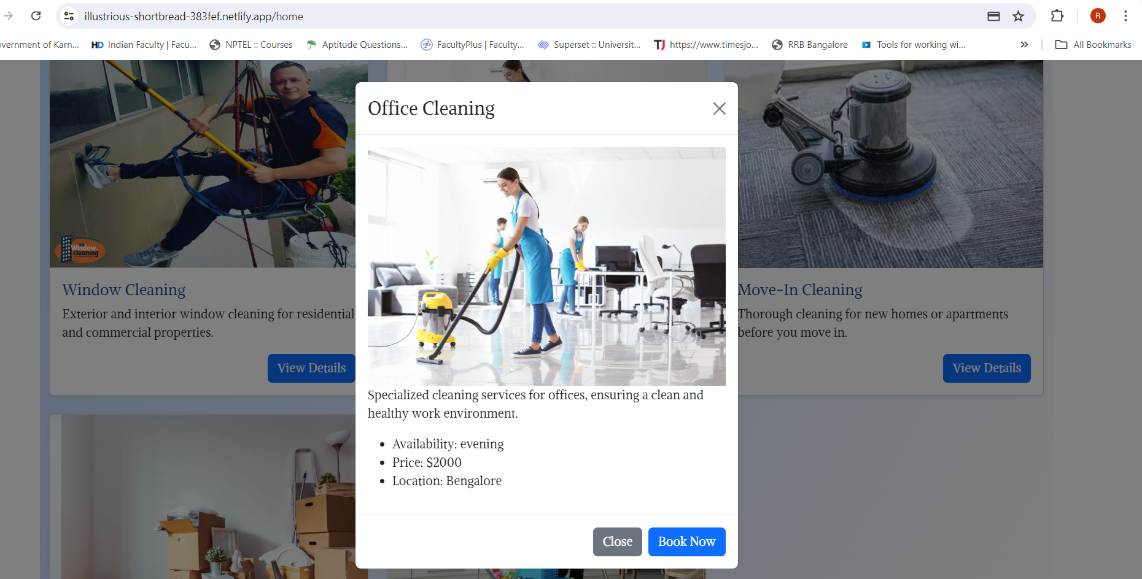

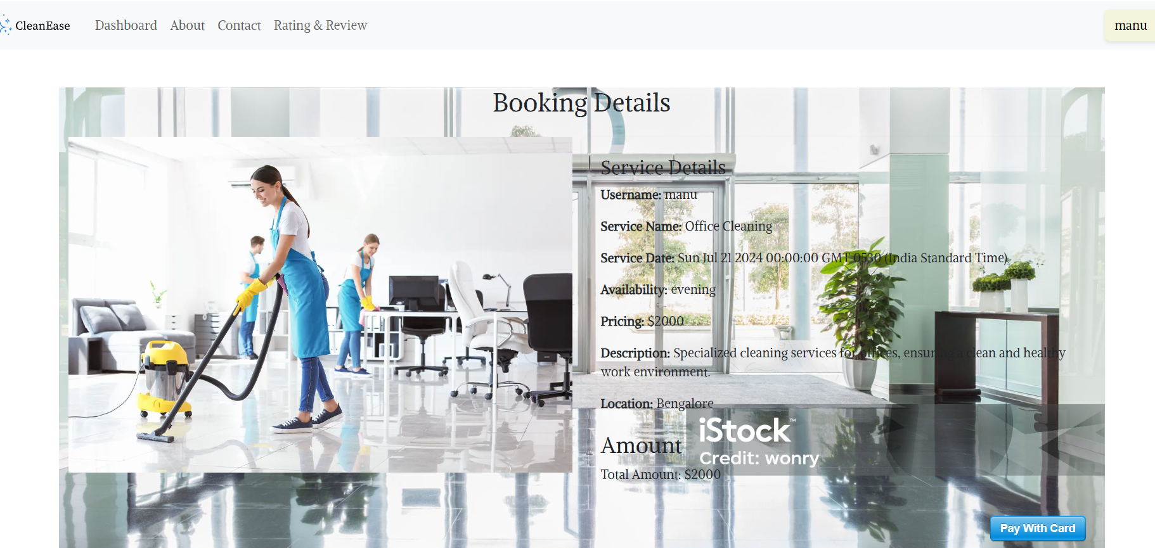

### 7. Payment

Users can see the payment details after clicking pay now button. After it will redirect to home page.

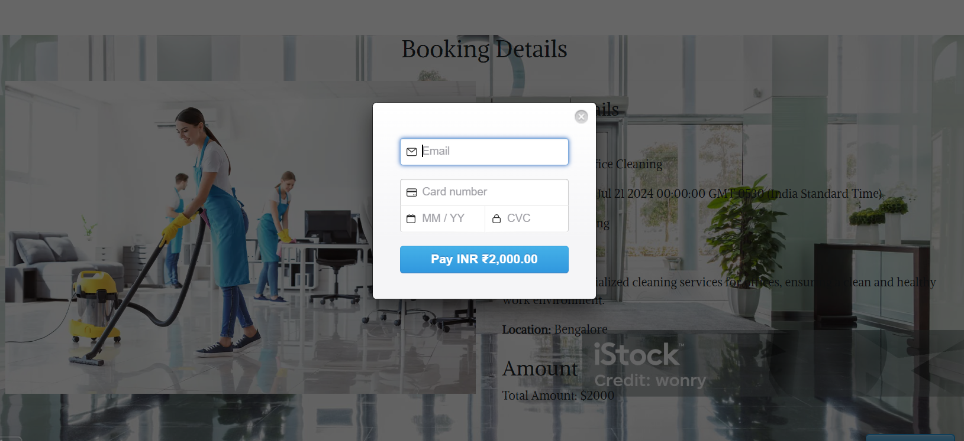

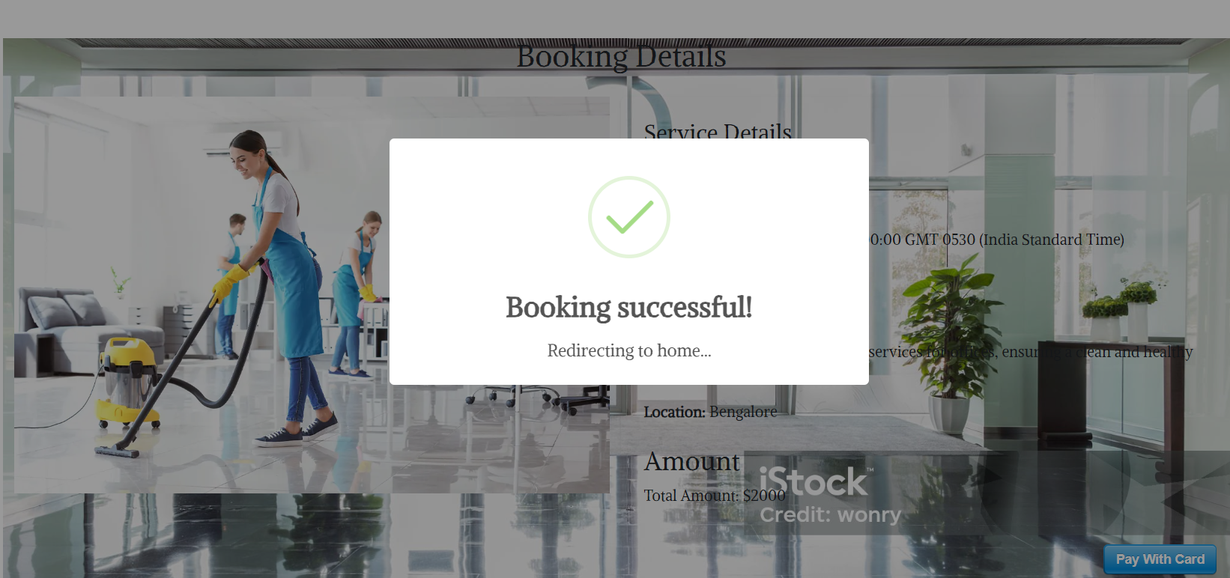

### 8. User Profile

Users can see their profile by clicking dropdown

After user can see their profile.

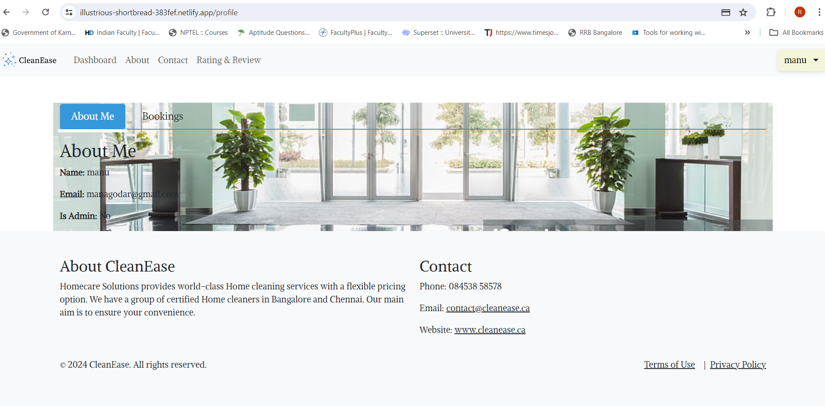

After user can see their bookings.

